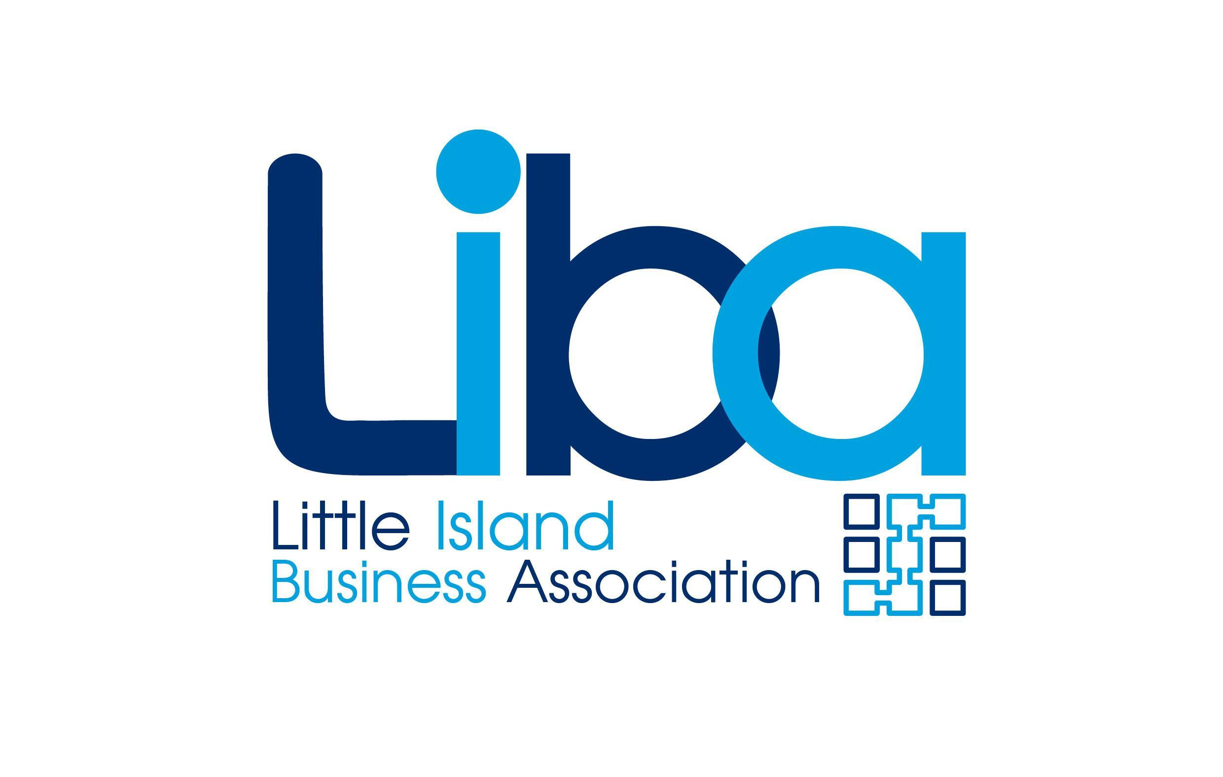

Little Island Business Association Membership Form

PLEASE SELECT YOUR ANNUAL MEMBERSHIP:
- 1 - 10 employees €500.00 (+ VAT)
- 11 - 100 employees €900.00 (+ VAT)
- 101+ employees €2,000.00 (+ VAT)

The following information you provide will not be published and will only be available to the necessary staff members within Little Island Business Association to provide you with the services for which you have signed up.
Contact person’s details | Name
 | Phone
 | Email
The following information you provide is to be published as part of the Little Island Business Association directory and as such is for the public and available to the public.

Company details | Full name
 | Address
 | Website
 | Phone
 | Email
Category you would like to be listed under (eg finance, beauty etc)
The following information you provide will be available in our in-house contact database and will be used for us to follow you and share your business activities, which is part of our service. We require usernames only.
 | Facebook
 | Twitter
 | Instagram
 | LinkedIn
 | Snapchat
 | YouTube

Please check all information carefully before returning. We will not accept any liability for errors after final approval.
Payment Method
Payment terms and details
- Payment to be made with order.
- By bank transfer to the account of:
Culhamy Consulting Limited at AIB Bank, Eastgate Village, Little Island, Cork
Sort code: 93 41 27
Account no.: 39669054
IBAN: IE96AIBK93412739669054
BIC: AIBKIE2D
Please reference your name on the bank transfer.
- Debit or credit card payment facility is also available.

Little Island Business Association is a trading name of Culhamy Consulting Limited and this order is processed by Culhamy Consulting Limited.
Terms and Conditions
Once the following elements of the Recommended Membership have been enacted, no changes can be made to the programme for the client other than if the client wishes to cancel the agreement. This will result in the loss of any remaining period and value, as no refunds are given after material is published and on a recommendation basis on social media.
- Inclusion of the advertisement or editorial on Little Island Business Association website or in weekly newsletter.
- Recommendation on social media published by a Little Island Business Association agency.
Please Note: By agreeing to become a Member, you consent to receiving email and marketing communications relating to your membership.
Please Note: Little Island Business Association will not share your information with any third party or authorise any body to use it for direct marketing purposes to you.

Signature: Date: __________________

For office use only
Signed up by:
Renewal: | ⃝ | New Client: | ⃝
Assigned client number:
Membership period:
Cost:
Notes:

